**Symphony of Sirens (Baku)**

Adrian Curtin

*The* *Symphony of Sirens* was a mass concert designed by Arseny Avraamov (1886-1944) that took place in Baku on November 7, 1922. It aimed to recreate in sound and movement the storming of the Winter Palace in St. Petersburg in 1917, transposing this event onto the capital city of the Azerbaijan Soviet Socialist Republic. Avraamov’s symphony was a grandiose expression of proletarian music-making, i.e. music made by and for workers, featuring ‘instruments’ of modern technology and industry that workers could ‘perform’ themselves, such as factory whistles, guns, and modes of transportation. Avraamov instructed performers to make a scheduled panoply of everyday and ceremonial sounds at various locations in the city. These sounds included cannon fire, foghorns, fireworks, bells, sirens, automobile engines, gunfire, and aerial flights, in addition to the musical offerings of a specially built steam whistle machine that piped the notes of “The Internationale”, sung *en masse* at the symphony’s conclusion. Avraamov thus figuratively turned Baku into a giant, conjoint stage/auditorium/musical instrument. Ideologically, the work strove to consolidate the Soviet takeover of Azerbaijan, re-inscribe the founding narrative of the October Revolution, advance the cause of the international proletarian movement, and celebrate ‘liberated’ modern industry, technology, and the urban environment.

References and further reading

ALARCON, M. M. 2008. *Baku: Symphony of Sirens: Sound Experiments in the Russian Avant-Garde,* London, ReR Megacorp. (An annotated book and double-CD collection of sound recordings of the Russian avant-garde, including a recording of a reconstruction of Avraamov's symphony.)

AVRAAMOV, A. 1992. The Symphony of Sirens (1923). *In:* KAHN, D. & WHITEHEAD, G. (eds.) *Wireless Imagination: Sound, Radio, and the Avant-Garde.* Cambridge, Mass.; London: MIT Press. (An English translation of Avraamov's directions for how to perform his symphony.)

EDMUNDS, N. 2000. *The Soviet Proletarian Music Movement,* Oxford; New York, Peter Lang. (Provides an account of the historical, cultural, and political milieu in which Avraamov's work was composed.)

Paratextual Material

1.

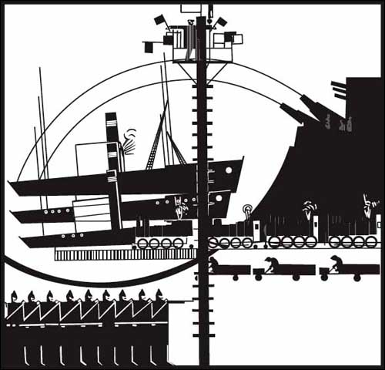

**Illustration of Avraamov, atop a tower, conducting *The Symphony of Sirens***

**Source: ‘Sinfoniia Gudkov,’ *Gorn* 9 (1923), p. 113 [likely out of copyright]**

2. Recorded reconstruction (available in the Alarcon book in the references list), posted to YouTube: <http://www.youtube.com/watch?v=Kq_7w9RHvpQ> [copyright permission required, presumably]